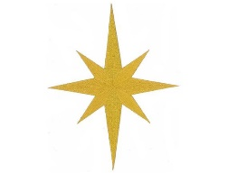
Nativity Characters Competition

Can you create a character from the nativity using items from your home? It can be big or small made indoors or outdoors and can be made out of anything you can find. Send us a picture of what you have made for the chance to win a Christmas hamper. All profits will be donated to the church.
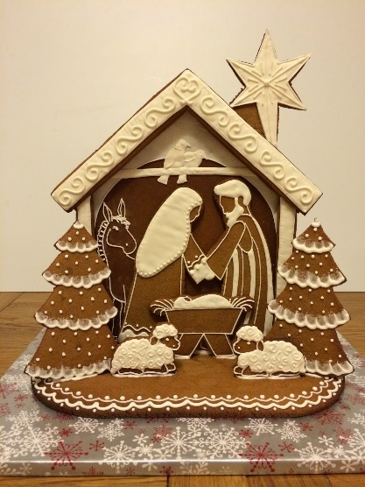
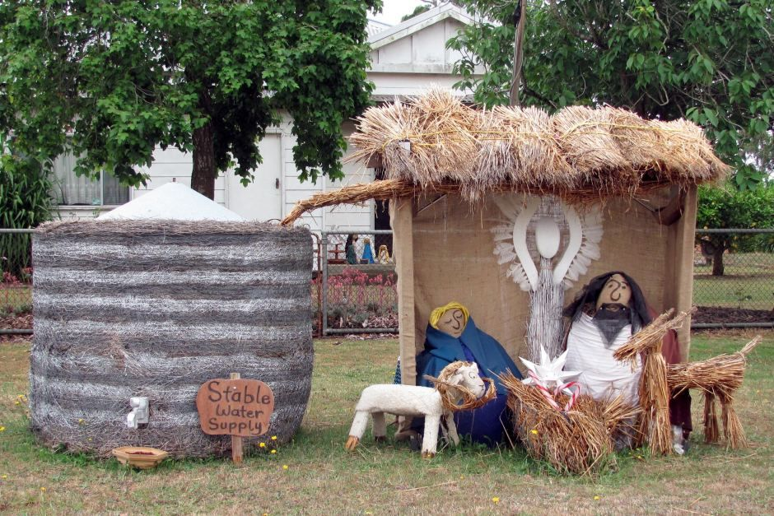
Adults
Entry cost - £3.50

Older Children (10-18 years)
Entry cost - £2.50

Younger Children (0-10 years)
Entry cost £1.50

To take part please get in contact with Dave or Nik Burton on 01884 561499 or E-mail david.burton@doivedesigns.co.uk Entries must be received by 10th December and the winners will be announced on the 12th December Via a Zoom meeting. Details of this will be sent out when entries are received. Have fun and good luck!
